University APP

Member Names:

1. Ahmed Yassin Ashraf Ibrahim
2. Mohammed Ahmed Qarni Owais
3. Abdulrahman Hamdi Hassan
4. Ibrahim Ashraf Abdul Rauf

Files Methods:

1. 
2. 
3. 
4. 
5. 
6. 
7. 

XML Files:

1. 
2. 

Operations: 1.

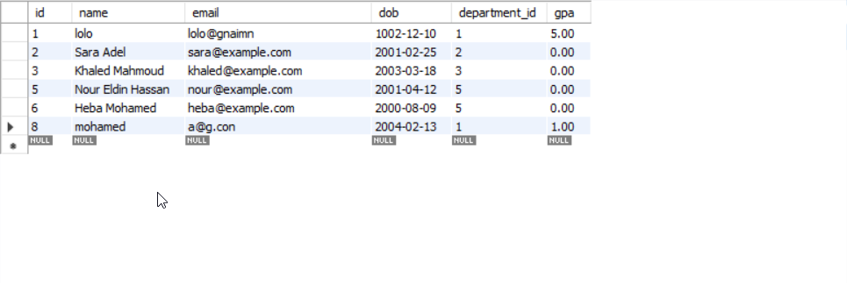

**2.**

3.

4.

5.

Note: You need to enable editing to open the files 📂.

Or / you can take all the files “ Copy ” and put them on your computer.